**Package & Freight Receiving Management Application**

User Manual

Table of Contents

|  |  |
| --- | --- |
| Introduction | 1 |
| Getting Started | 2 |
|  |  |
|  |  |
|  |  |
|  |  |
|  |  |
|  |  |

Introduction

This application is specifically designed to allow Ozarks Technical Community College’s Shipping and Receiving Management Office to accurately and efficiently receive, track, and distribute freight throughout the college and its campuses. Using a remote database this application stores packages and their status as well as other common and important information. Creating reports, delivery sheets, and list print out are made easily through the various menus and interfaces offered by the application.

Getting Started

Installing the application:

Insert the disc provided into the computers disk drive.

When prompted click install and run. This make take a couple minutes.

Once installed, double click on the icon on the desktop to start the application.

When the application starts you will be prompted to log in.

For first time setup use the Username: Admin and the Password: Admin.

Logging in for the First Time

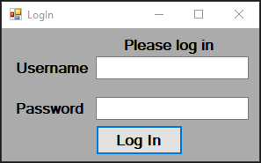Once the application starts, you will be prompted to login. For first-time login used the USERNAME: admin and the PASSWORD: admin. (Once initial setup is complete, and an administrative user created this username and password will no longer allow you to login).

After successfully logging in, the Main Menu will load. You will be presented with four buttons Receiving, History, Manage, and Settings. To complete initial setup, click Settings.

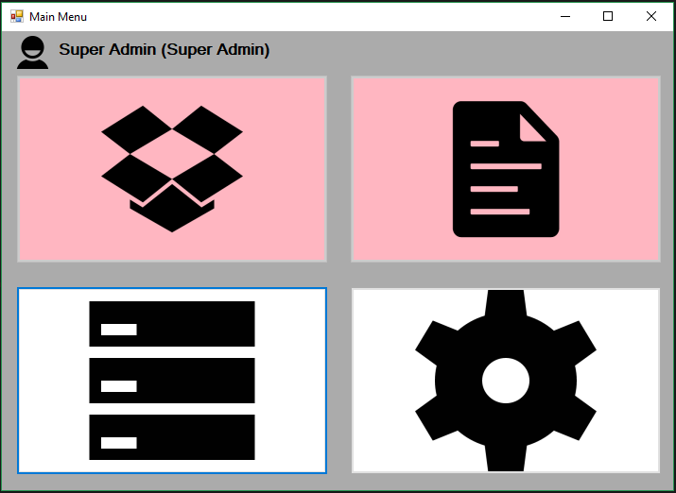

Manage

Settings

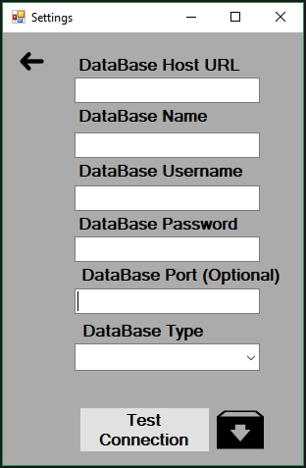In the Settings menu, you will need to enter the database connection information. To get this information contact your database administrator. Once you have entered the connection information test the connect by pressing the test connection button. If the connection is successful, a pop-up with a “Connection Successful” will display. After the connection displays success message displays, use the “Save Connection” button to save the connection information. When you click the “Save Connection” button the application will restart so that the connection can be active through-out the application.

Save Connections

Once prompted, login using the setup password and username. In the Main Menu click Manage to start the process of creating an Admirative User. In the Manage Menu click the User button to set the table to User and then click the Add button.

In the Add window add the requested information. (It is important that the first user be an Administrator so that you have access to all functions in the application). For more information about adding a user see Manage: Users.